CS 6375

ASSIGNMENT __3__________

Names of students in your group:

Pranathi Peri(pxp162530)

Nithin Vasireddy(nxv160230)

Number of free late days used: ___0_________________   
Note: You are allowed a **total** of 4 free late days for the **entire semester**. You can use at most 2 for each assignment. After that, there will be a penalty of 10% for each late day.

Please list clearly all the sources/references that you have used in this assignment.

**Read Me File**

**Language used:** Python

**Steps to run the Code:**

1)To run the file you have install numpy package first and traverse to the path where the files are present and run them.

2)Run the file neural.py which is the file for preprocessing. As arguments to this package send the input file name and output file name.

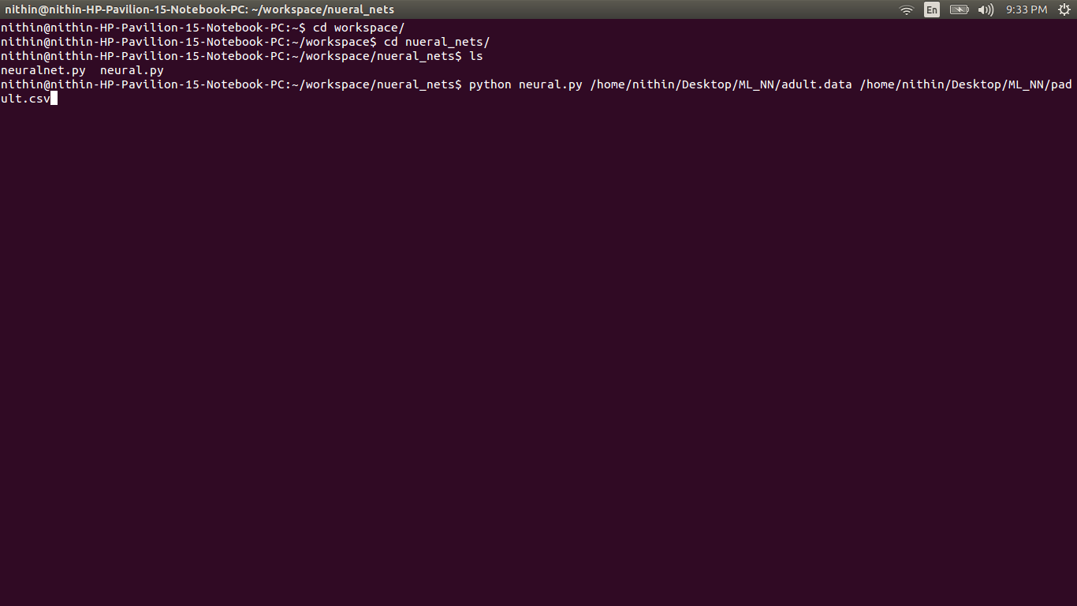

3)Run the file neuralnet.py which is the file for the neural net. To this file pass as arguments the preprocessed file, training percent, error tolerance, no.of hidden layers, no of neurons in each layer.

